CS422 Computer Networks (Fall 2025): Homework 4
- (10 points) Consider the topology shown in Figure 1. Denote the three subnets with hosts (starting 1 clockwise at 12:00) as Networks A, B, and C. Denote the subnets without hosts as Networks D, E, and F.
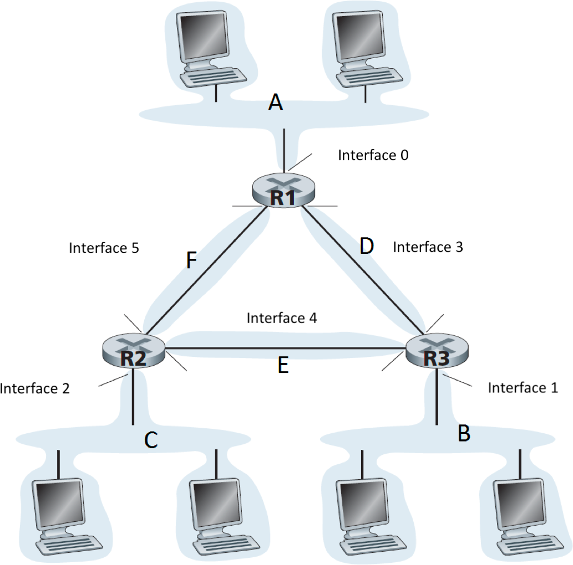

Figure 1: Three routers connecting six subnet

  - Assign network addresses to each of these six subnets, with the following constraints: All addresses must be allocated from 214.97.254.0/23; Subnet A should have enough addresses to support 250 interfaces; Subnet B should have enough addresses to support 120 interfaces; and Subnet C should have enough addresses to support 120 interfaces. Of course, subnets D, E and F should each be able to support two interfaces. For each subnet, the assignment should take the forma.b.c.d/x or a.b.c.d/x - e.f.g.h/y.

- Subnet A: 214.97.255.0/24
- Subnet B: 214.97.254.0/25
- Subnet C: 214.97.254.128/25
- Subnet D: 214.97.255.0/31
- Subnet E: 214.97.254.2/31
- Subnet F: 214.97.254.4/31

  - Using your answer to part (a), provide the forwarding tables (using longest prefix matching) for each of the three routers.

R1
Prefix | Mask | Interface
214.97.255.0 | /24 | 0
214.97.254.0 | /31 | 2
214.97.254.4 | /31 | 1
214.97.254.0 | /25 | 2
214.97.254.128 | /25 | 1
214.97.254.2 | /31 | 1
R2
Prefix | Mask | Interface
214.97.254.128 | /25 | 0
214.97.254.2 | /31 | 2
214.97.254.4 | /31 | 1
214.97.253.0 | /25 | 2
214.97.255.0 | /24 | 1
214.97.254.0 | /31 | 2
R3
Prefix | Mask | Interface
214.97.254.0 | /25 | 0
214.97.254.0 | /31 | 1
214.97.254.2 | /31 | 2
214.97.254.0 | /24 | 1
214.97.254.128 | /25 | 2
214.97.254.4 | /31 | 2

- (10 points) Consider the SDN OpenFlow network shown in Figure 2. Suppose we want switch s2 to function as a firewall. Specify the flow table in s2 that implements the following firewall behaviors (specify a different flow table for each of the four firewalling behaviors below) for delivery of datagrams destined to h3 and h4. You do not need to specify the forwarding behavior in s2 that forwards traffic to other routers.
  - Only traffic arriving from hosts h1 and h6 should be delivered to hosts h3 or h4 (i.e., that arriving traffic from hosts h2 and h5 is blocked).

Match Field | Action
Src_ip = 10.1.0.1 / Dst_ip =10.3.0.3 | Output = 3
Src_ip = 10.1.0.1 / Dst_ip =10.3.0.4 | Output = 4
Src_ip = 10.2.0.6 / Dst_ip = 10.3.0.3 | Output = 3
Src_ip = 10.2.0.6 / Dst_ip = 10.3.0.4 | Output = 3
Src_ip = 10.3.0.3 or 10.3.0.4 | Drop

  - Only TCP traffic is allowed to be delivered to host h3 or host h4 (i.e., that UDP traffic is blocked).

Match Field | Action
Prot_ip = TCP / Dst_ip =10.3.0.3 | Output = 3
Prot_ip = TCP / Dst_ip =10.3.0.4 | Output = 4
Dst_ip = 10.3.0.3 or 10.3.0.4 | Drop

  - Only traffic destined to h3 is to be delivered (i.e., all traffic to h4 is blocked).

Match Field | Action
Src_ip = 10.1.0.1/ Dst_ip = 10.3.0.3 / Prot_ip = UDP | Output = 3
* | Drop

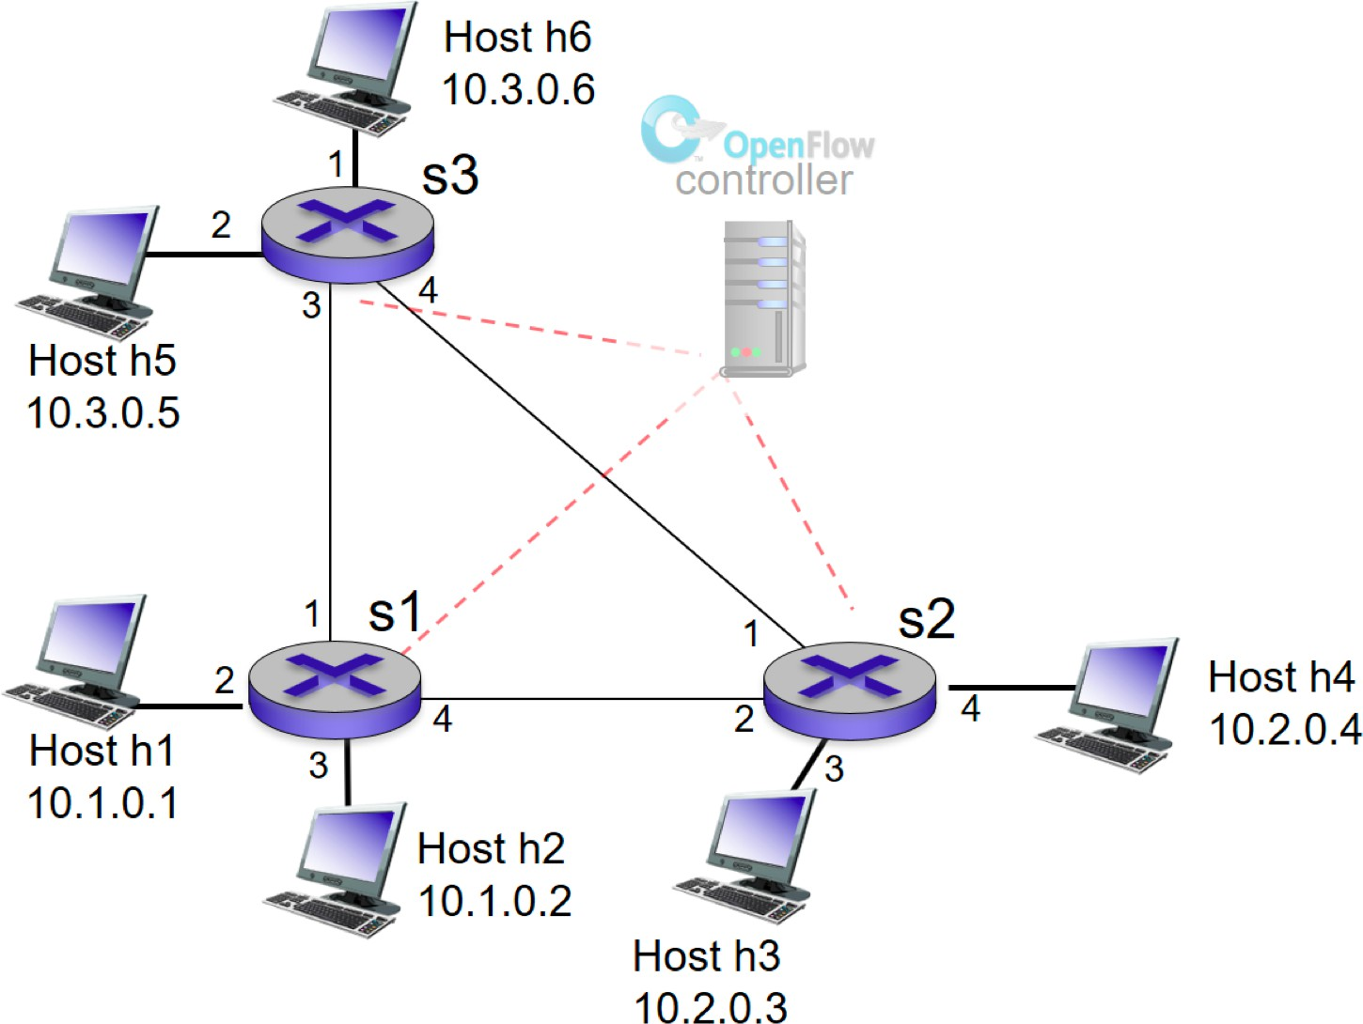

Figure 2: OpenFlow match-plus-action network with three packet switches, 6 host, and an OpenFlow controller

  - Only UDP traffic from h1 and destined to h3 is to be delivered. All other traffic is blocked.

Match Field | Value
Src_ip | 10.1.0.1
Dst_ip | 10.3.0.3
Ip_proto | UDP
Action | Forward

- (10 points) Consider the following network as shown in Figure 3. With the indicated link costs, please use Dijkstra’s shortest-path algorithm to compute the shortest path from x to all network nodes. Show how the algorithm works by computing the table similar to the one in the lecture slide. Finally, show the forward table at node x.
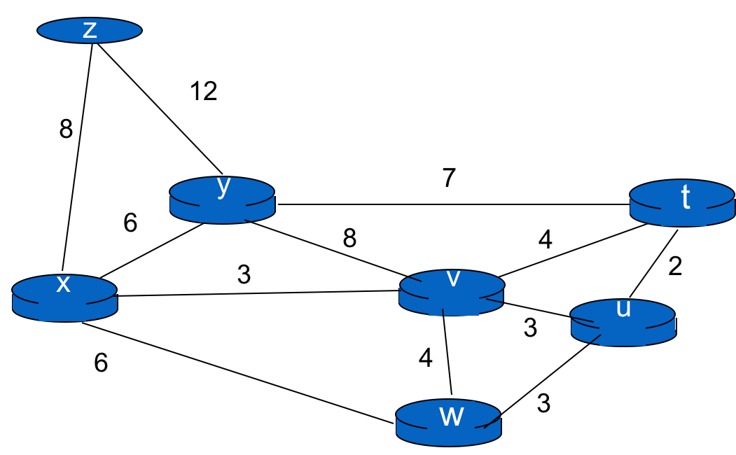
Step | N | D(u)/p(u) | D(v)/p(v) | D(w)/p(w) | D(y)/p(y) | D(z)/p(z) | D(t)/p(t)
0 | x | ∞ | 3, x | 6, x | 6, x | 8, x | ∞
1 | x v | 6, v | 3, x | 6, x | 6, x | 8, x | 7, v
2 | x v w | 6, v | 3, x | 6, x | 6, x | 8, x | 7, v
3 | x v w y | 6, v | 3, x | 6, x | 6, x | 8, x | 7, v
4 | x v w y u | 6, v | 3, x | 6, x | 6, x | 8, x | 7, v
5 | x v w y u t | 6, v | 3, x | 6, x | 6, x | 8, x | 7, v
6 | x v w y u t z | 6, v | 3, x | 6, x | 6, x | 8, x | 7, v

Destination | Link
U | (x,v)
V | (x,v)
W | (x,w)
Y | (x,y)
Z | (x,z)
T | (x,v)

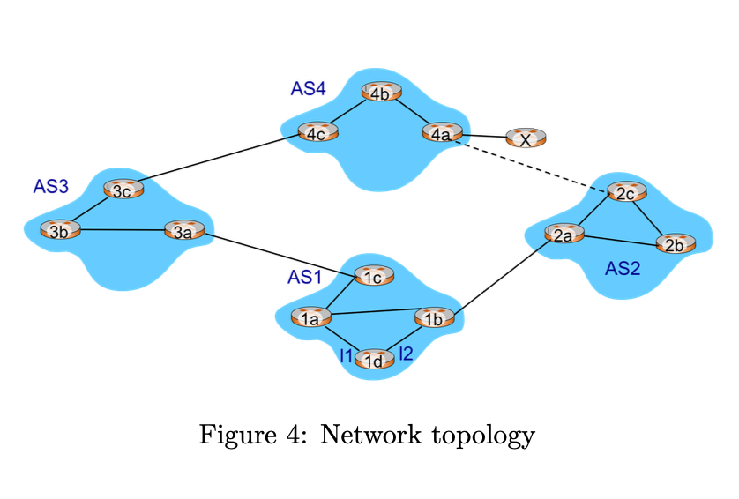

- (10 points) Consider the network shown in Figure 4. Suppose AS3 and AS2 are running OSPF for intra-AS routing. AS1 and AS4 are running IS-IS intra-AS routing. Suppose both eBGP and iBGP are used for inter-AS routing. Initially, there is no physical link between AS2 and AS4.
  - Router 3c learns prefix x from which routing protocol? OSPF, IS-IS, eBGP, iBGP?
eBGP

  - Router 3a learns prefix x from which routing protocol?

iBGP

  - Router 1c learns prefix x from which routing protocol?

eBGP

  - Router 1d learns prefix x from which routing protocol?

iBGP

  - Once Router 1d learns prefix x, it will put an entry (x,I) into its forwarding table. Will I be I1 or I2 for this entry? Explain why in one sentence?

I1, because the only path to x is via AS3 which is reached through I1.

  - Now support there is a physical link between AS2 and AS4, shown in the dotted line. Support router 1d learns that x is accessible via AS2 as well as via AS3. Assume that each link cost is equal (say, 1). Will I be I1 or I2 for this entry? Explain why in one sentence?

I2, because even with the additional path via AS2-AS4, the shorter AS path via AS4 is preferred despite equal link cost of 1.

